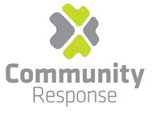

Community Response in conjunction with the Ballyfermot, Canal Communities, Dublin 12 and South Inner-City Drug and
Alcohol Task Forces invite applications for the following position:
Secondments will be considered

Alcohol Link Worker
Full-time 35 hours (1-year fixed term contract)

The role: The person will act as the lead contact for the establishment interagency work and the development and implementation of the community alcohol detox project across the four task force areas. This will include working with predominantly addiction funded projects across the four Task Force areas, to strengthen the interagency model of practice under the National Drug Rehabilitation Framework and to develop a best practice model for a Community Alcohol Detox project.

Reporting: The Alcohol Link Worker will report on a day-to-day basis to the Project Manager of Community Response and their work will be informed and guided by the Project Management Group (PMG).

Target group
The project aims to reach out to people who may face barriers to entering residential detox or not wishing/able to engage with existing drug and alcohol services. The Community Alcohol Detox Project has identified the following as the primary target groups:

People not currently engaged with drug or alcohol services or who do not find it safe to access such projects | Members of the Traveller community
Parents with childcare requirements unable to attend residential services | New Communities
People in employment | Older persons
People who cannot access services because of disability or mobility | People with co-morbid mental health and substance use problems
Service users of the Probation Services | Lesbian, gay, bisexual, transgender, and intersex communities
People using homeless services | Sex Workers

Job description
The successful candidate will:

- Broker an in-reach arrangement with James's hospital A&E to strengthen the referral from emergency hospital settings to community-based supports for individuals where problematic alcohol use is an issue.

- To generate robust links with the Community GPs, Primary Care services and James’s Hospital and other identified stakeholders.

- Be a point of contact for identified community-based projects and/or referral agents, signposting people to suitable local services

- Support existing projects in each Task Force area to strengthen their capacity to respond to service users /people who require an alcohol detox OR reduce their alcohol use through a non –residential setting.

- Promote and support service user involvement mechanisms to inform policy and service development.

- To work with the project management group and external consultant on service users and services to review, design and deliver suitable supports.

- Signpost projects to existing training packages (e.g, SAOR) or to relevant organisations to support Tier 1-2 services to identify and respond to the needs of people looking to address their alcohol use through detox.

- Reinforce the principles of National Drug Rehabilitation Framework as a model for inter-agency practice and improve interagency work across sectors by way of developing training and other materials for stakeholder.

- Provide guidance and support to generate integrated practices in service and care pathways for individuals, family and significant others.

- Gather and collate information on the Key Performance Indicators (KPI) across services and have consistent data management for this initiative in conjunction with the PMG.

The above job description is not intended to be a comprehensive list of all duties involved and consequently, the post holder may be required to perform other duties as appropriate to the post which may be assigned to him/her from time to time and contribute to the development of the post while in office.

This post has received approval for a secondment arrangement.

Person specification:
Each candidate must possess the requisite knowledge and ability (including a high standard of suitability) for the proper discharge of the duties of the post. Upon offer of contract, the successful candidate will be required to provide:

- Subject to three satisfactory work references including most recent employer
- Original documentation for all qualification requirements for the post.
- Offers will be subject to Community Response’s Garda Vetting process.

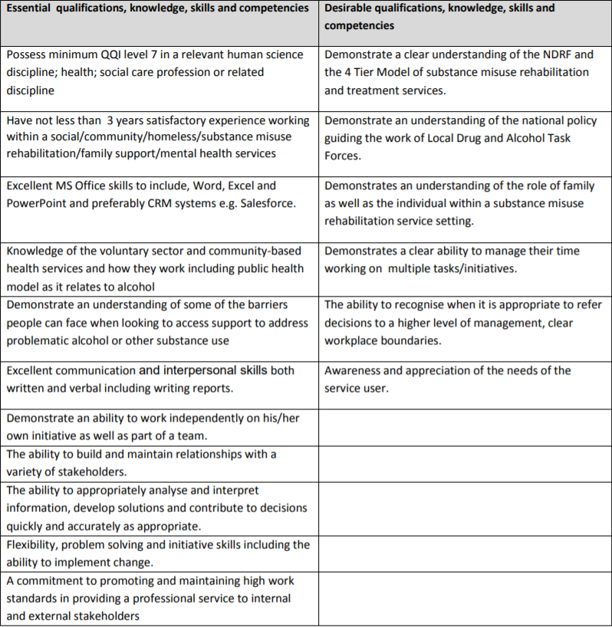

Remuneration:

The Salary for this post is HSE Clerical Officer Grade V

Location:

The post will be based in Community Response premises in Carman’s Hall, Dublin 8 but the person will be expected to work across the four Task Force areas, access to own transport would be desirable.

Send a current CV and Covering Letter to: | recruitment@communityresponse.ie
Closing Date: | 17th May @ 5.00pm
Informal Enquiries to | Nicola Perry @ 01 454 9772 or email nicola@communityresponse.ie

Only Shortlisted Candidates will be contacted for Interview

Community Response is an Equal Opportunities Employer

Funded through and supported by

